Model Building Test The Model

|  |  |
| --- | --- |
| Date | 08 -11- 2022 |
| Team ID | PNT2022TMID13897 |
| Project Name | AI-Powered Nutrition Analyzer For Fitness Enthusiasts |

Load the saved model using load_model

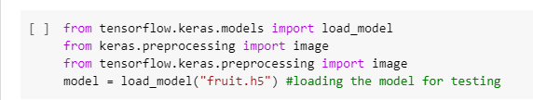

Taking an image as input and checking the results :

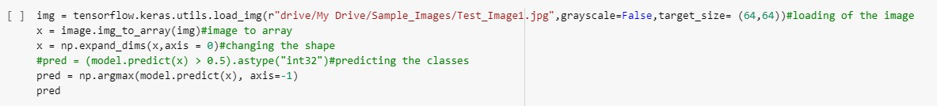

By using the model we are predicting the output for the given input image

